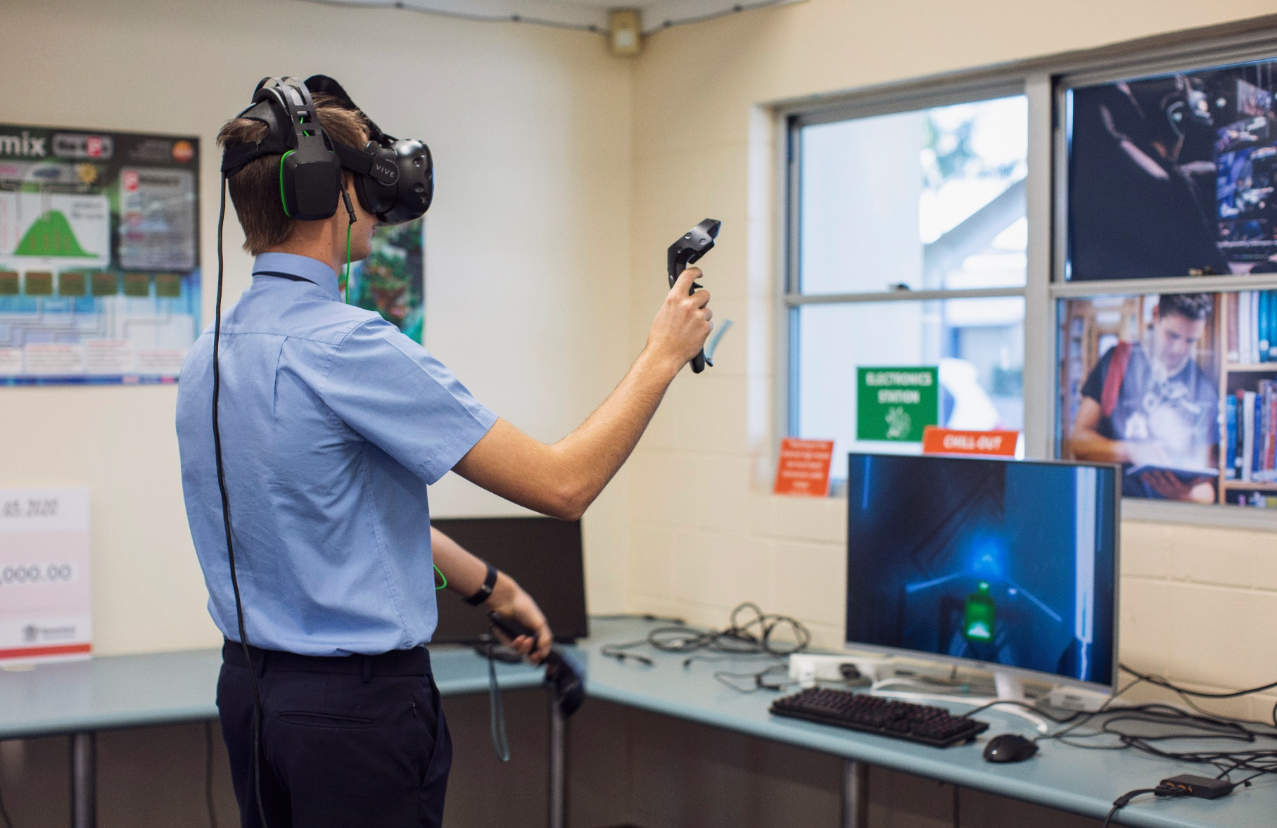
FEES AND LEVIES SCHEDULE
2023

College Fees & Levies
The fees and levies collected are used for specialised staff, resources, materials, facilities, and equipment.
St Mary’s College as a non-government school, does not receive sufficient grants from the Commonwealth and State Governments to cover all running costs and is heavily reliant on families ensuring fees and levies are paid.
St Mary’s College invoice fees and levies under a largely inclusive fee structure, giving parents the security of financially planning with no hidden costs.
Fees and levies are invoiced per term, payment options are outlined on page 4.
1st Child | Year 12 | Year 11 | Year 10 | Year 9 | Year 8 | Year 7
Tuition Fee | $2132 | $2132 | $2132 | $2132 | $2132 | $2132
Capital Levy | $680 | $680 | $680 | $680 | $680 | $680
Parent Levy | $110 | $110 | $110 | $110 | $110 | $110
Resource Levy | $750 | $750 | $750 | $575 | $575 | $575
Technology Levy | $485 | $485 | $485 | $485 | $485 | $485
Camp/Retreat Levy | $135 | $385 |  | $580 |  | $380
Total per year | $4292 | $4542 | $4157 | $4562 | $3982 | $4362
Total per term | $1073 | $1135.50 | $1039.25 | $1140.50 | $995.50 | $1090.50
Total per week (52 Weeks) | $83 | $88 | $80 | $88 | $77 | $84

2nd Child | Year 12 | Year 11 | Year 10 | Year 9 | Year 8 | Year 7
Tuition Fee | $1240 | $1240 | $1240 | $1240 | $1240 | $1240
Resource Levy | $750 | $750 | $750 | $575 | $575 | $575
Technology Levy | $485 | $485 | $485 | $485 | $485 | $485
Camp/Retreat Levy | $135 | $385 |  | $580 |  | $380
Total per year | $2610 | $2860 | $2475 | $2880 | $2300 | $2680
Total per term | $652.50 | $715 | $618.75 | $720 | $575 | $670
Total per week (52 weeks) | $51 | $55 | $48 | $56 | $45 | $52

3rd Child | Year 12 | Year 11 | Year 10 | Year 9 | Year 8 | Year 7
Tuition Fee | $640 | $640 | $640 | $640 | $640 | $640
Resource Levy | $750 | $750 | $750 | $575 | $575 | $575
Technology Levy | $485 | $485 | $485 | $485 | $485 | $485
Camp/Retreat Levy | $135 | $385 |  | $580 |  | $380
Total per year | $2010 | $2260 | $1875 | $2280 | $1700 | $2080
Total per term | $502.50 | $565 | $468.75 | $570 | $425 | $520
Total per week (52 weeks) | $39 | $44 | $36 | $44 | $33 | $40

4th Child | Year 12 | Year 11 | Year 10 | Year 9 | Year 8 | Year 7
Tuition Fee | $364 | $364 | $364 | $364 | $364 | $364
Resource Levy | $750 | $750 | $750 | $575 | $575 | $575
Technology Levy | $485 | $485 | $485 | $485 | $485 | $485
Camp/Retreat Levy | $135 | $385 |  | $580 |  | $380
Total per year | $1734 | $1984 | $1599 | $2004 | $1424 | $1804
Total per term | $433.50 | $496 | $399.75 | $501 | $356 | $451
Total per week (52 weeks) | $34 | $39 | $31 | $39 | $28 | $35

Fee Discounts
St Mary’s College offers a discount for families who have siblings at the following Primary Schools, St Mary’s Maryborough, Star of the Sea Hervey Bay and St Joseph’s Childers.
Tuition Fee Discount | Number of siblings at St Mary’s Primary, Star of the Sea  and St Josephs
No of students | One | Two | Three | Four
Discount off College fees | 5% | 10% | 20% | 40%

Capital Levy Discount
Families with children also attending St Mary’s Primary School will only pay one $680 Capital Levy across both Schools. Each School invoices the Capital Levy separately with a split of $277.50 invoiced by St Mary’s Primary School and $402.50 invoiced by St Mary’s College.
Certificate Courses
Offered to Year 11 and 12 (Total amount of the course is invoiced in 2023)
VETIS is government funding for a single Cert I or Cert II course per student. This funding can be accessed once only. The VETIS funded courses are those that have been deemed by industry as leading to employment.
Course Name | Course Cost
Cert III Sport and Recreation (2-year course, Cert II embedded) | $400
Cert III Visual Art (Cert II embedded) (2-year course) | $300
Cert III Early Childhood Education and Care (2-year course) | $1,800
Cert II Hospitality (1-year course) Cert III (available in year 2) | VETIS is available for Cert II or if VETIS has been used the cost is $1500 (approx.)  CERT III is a pay per module cost
Cert III Laboratory Skills (Cert II must be completed first) (1-year course) | $500
Certificate III in Information, Digital Media, and Technology (2-year course) | $500
Cert II Automotive Vocational Preparation, Cert II Electrotechnology, Cert II Health Support, Cert I Construction, Cert II Engineering Pathways, Cert II Furniture Making, Cert II Sampling and Measurement, Cert II Plumbing (1-year courses) | VETIS Funding
Cert IV Justice (2-year course) | $750, this course is run through Unity College and payable directly to Unity College
Cert II Salon Assistant (2-year course) | $100 fee payable to MSHS in Year 11  $100 fee payable to MSHS in Year 12  Students are required to purchase a uniform. Please see Pathways Centre for details.
Cert III Make-up (2-year course) | $100 fee payable to MSHS in Year 11  $100 fee payable to MSHS in Year 12  Students are required to purchase a professional brush kit $200 through MSHS.  Students are required to purchase a uniform. Please see Pathways Centre for details.

Distance Education Courses
Subject fees are negotiated at the time of enrolment application. This is dependent on the place of study.
Music Program
Details of the music program will be sent to all families at the start of the year.

Explanation of Levies
Resource Levy
- Inclusions: consumable items used for subjects, excursions, yearbook, most subject specific camps, pastoral care activities, St Mary’s College/Fraser District and Wide Bay Trials for Athletics, Cross Country, and Swimming Carnivals.
- Exceptions: any self-nominated activities e.g., Graduation Dinner, sporting teams not listed above etc.
Some overnight subject camps may incur an extra minimal charge which is payable at the time of the camp.

Technology Levy
- This levy supports the high level of information communication technology integration that the College provides.
- The levy will provide for and maintain our infrastructure – our high-volume broadband link, wireless network, interactive projectors, hardware, student1:1 laptop program, software and support of skilled personnel and services.

Parent Levy
- This levy enables the College to acquire equipment and resources to benefit students.

Year Level Camps
- All year level camps are compulsory. Approval for non-attendance and refunds must be addressed to the principal at smaryborough@bne.catholic.edu.au
- Information regarding camps and excursions will be emailed to families as they arise.

Capital Levy
- The compulsory Capital Levy per family ensures the College can continue building and maintaining facilities designed to optimise the learning environment for every student.

Payments
- Fees and levies are invoiced per term and emailed to families.
- Families can elect to pay weekly, fortnightly, monthly, by term or annually.
- Payment options are:
- Per Term
- BPAY
- Direct Debt (forms available from our Website, Parent Portal & Office)
- Credit Card
- Annually in Term 1
- EFT & Cash at College Office

Financial Agreement
- Signing of the Financial Agreement legally binds all parties jointly, severally & solely liable for the student’s fees and any other costs associated with the student’s attendance. The Financial Agreement will remain in force for the life of the enrolment of the student.
- Any changes in family circumstances must be documented in a ‘Revision of Financial Obligations’ form. Due to Brisbane Catholic Educations Privacy Policy, the College cannot discuss an account with anyone other than the account holder. It is the Parents responsibility to inform the College of any such changes in their relationship since signing the ‘Financial Agreement’ form (e.g., divorce, separation, bankruptcy). In the event of a breakdown in a relationship of a family, both parties remain jointly and severally liable for the payment of the school fees.
- Families who wish to have separate billing between two parents/guardians or third party must provide the College with the relevant signed authority.
- Where an account is outside the payment terms a student may not be eligible to participate in optional school trips and/or extra-curricular activities.

Termination of Enrolment
- Upon withdrawal from St Mary’s College an Exit Form must be completed and handed into the College office. Any refund of fees and levies will be applied as per the Fees, Levies Policy.

Concessions
- St Mary’s College is committed to providing an education to all children. We are also aware that some parents find themselves in financial difficulties from time to time. We have a formalised process for fee concessions which are available on application to any parent. Fee concessions are determined on a means–tested basis.
- Concessions are only granted on fees. All levies and camps must be paid in full. Fee Concession on accounts cannot be offered when families opt to pay for additional extra-curricular activities.
- Application forms can be found on our Parent Portal, College office or by emailing SMARfinance@bne.catholic.edu.au
- Concession must be reapplied for each year and are only offered for a maximum period of 12 months within a calendar year.

Enquiries
- If you require any assistance, please direct your enquiry to the College Finance Secretary at SMARfinance@bne.catholic.edu.au, 4190 2200 or in person at the College office.

