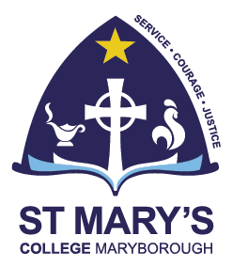
Scholarship Application Form
Year 7 2025

Applications open Monday 15 April 2024 and close Friday 13 September 2024 at 4.00pm.

Personal Details
First Name: | Surname:
Gender: | Date of Birth:
Primary School:
Parent/Caregiver Name:
Mailing Address:
Telephone No: |  | Mobile No:
Email Address:
Academic Awards (e.g. from school competitions, other competitions)
Extra-curricular involvement at your current school (e.g. Sport, the Arts, Debating, Tournament of Minds etc.)
School and Community Service
Other interests
Please write a brief statement regarding how you believe that you may contribute to and benefit from education at St Mary’s College
(200 words)

